I have committed my code .

* <https://github.com/asharma062001/AngularAssignment>
* After git clone please run : Install NPM command
* Npm start

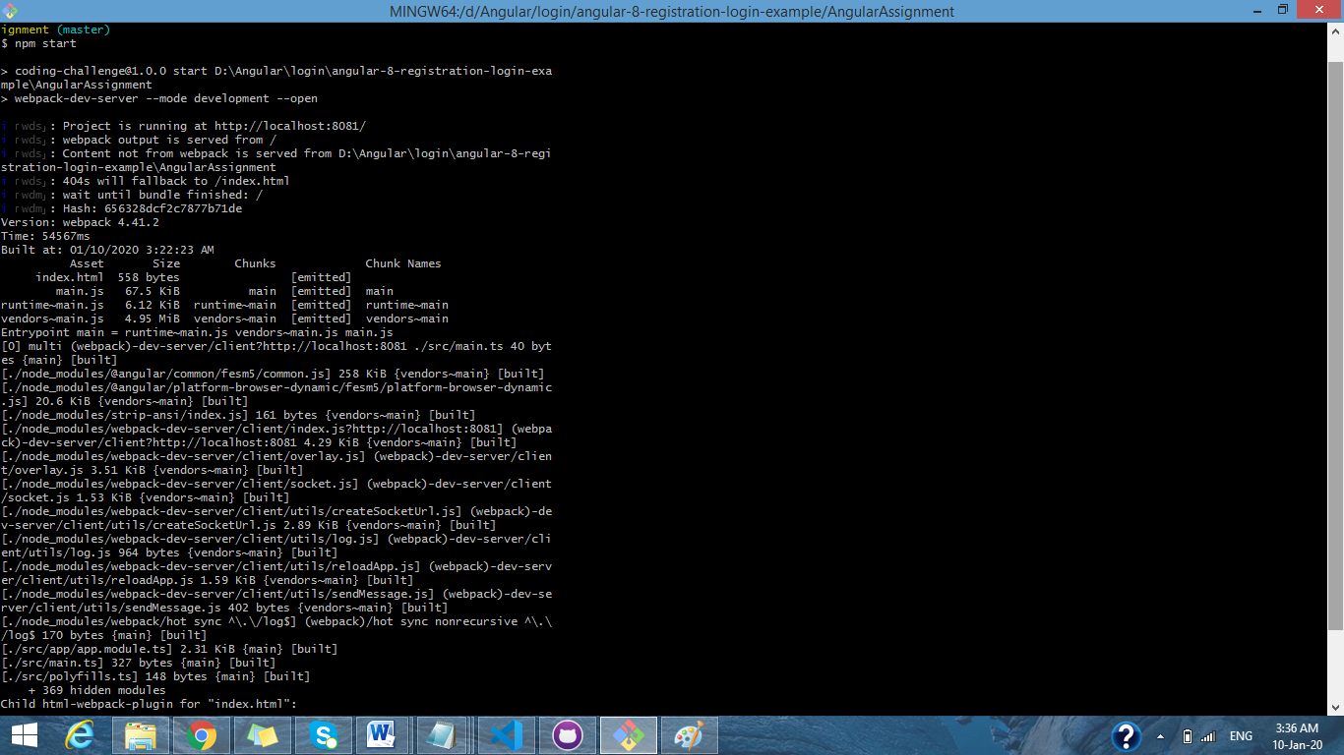

1) A simple login page to redirect employee page or manager page

Basic validation

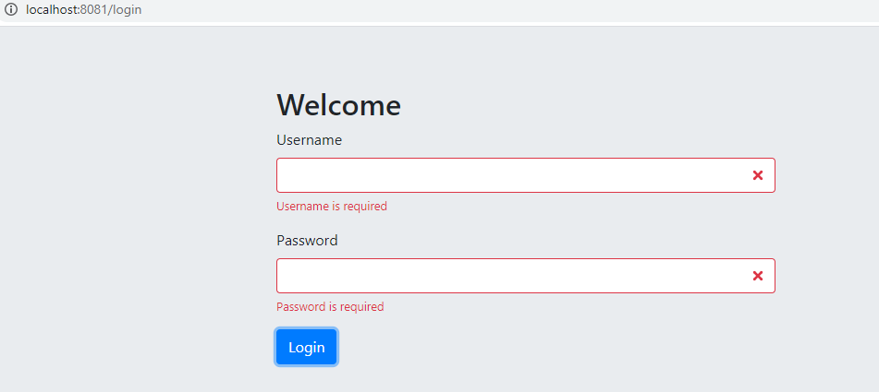

User name : test

Password: test.

* You can type anything it will allow login .

After login home page will display.

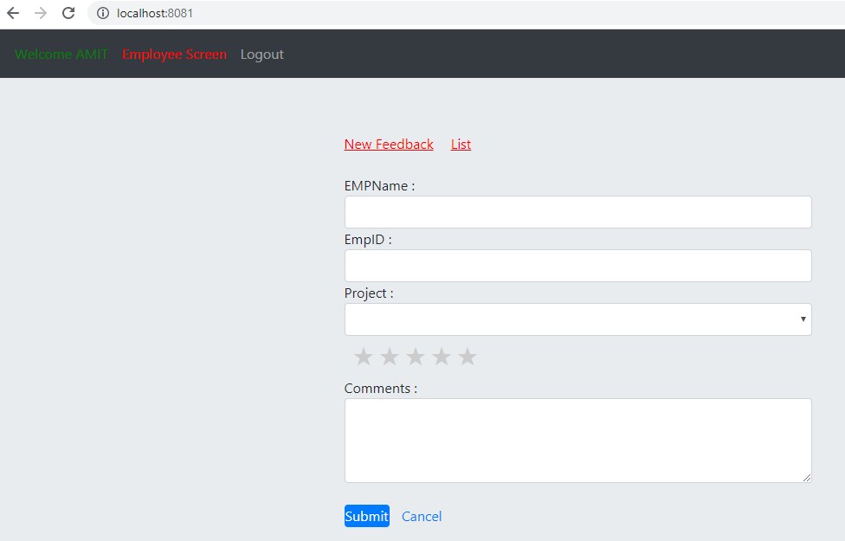

Basic validation

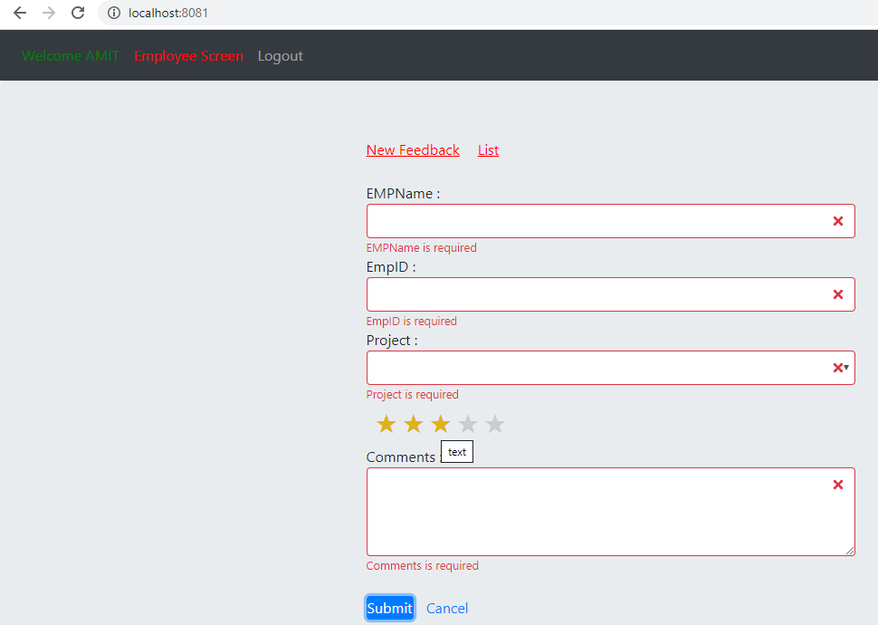

a) As Employee I should be able give feedback for each project. (Completed)

b) I should be able to see list of feedbacks which I gave per project. . (Completed)

c) Feedback list must contain below details and manager review (Manager rating and comments). . (Completed)

d) Form should have EmpName, EmpId, ProjectName, Comments and selfRating(stars-\*)

\*-bad, \*\*-poor, \*\*\*-Average, \*\*\*\*-good, \*\*\*\*\*-Excellent. e) Add basic validation. . (Completed)

After submit information will store in local storage .

